
Architecture Governance & Management
EA Blueprint
SGLines
Table of Contents
1 Governance Management Structure and Role and Responsibilities 3
2 Processes for Architecture Compliance, Exceptions and Vitality 4
3 Governance Policies 5
4 Governance Practices 6
5 Skeletal Communication Plan 7
6 Change Management Process 8
7 Guidance to Outsourcing Initiative 9
8 Metrics to Measure Effectiveness 10

Document Information
Project Name: | EA Blueprint for SGLines
Prepared By: |  | Document Version No: | 0.1
Title: | Architecture Governance & Management | Document Version Date:
Reviewed By: |  | Review Date: | 11/05/2014
Distribution List
From | Date | Phone/Fax/Email

To | Action* | Due Date | Phone/Fax/Email
* Action Types: Approve, Review, Inform, File, Action Required, Attend Meeting, Other (please specify)
Document Version History
Version  Number | Version  Date | Revised By | Description | Filename

Governance Management Structure and Role and Responsibilities
The governance of the Enterprise Architecture is overseen by the Governance Management as described in the structure below.
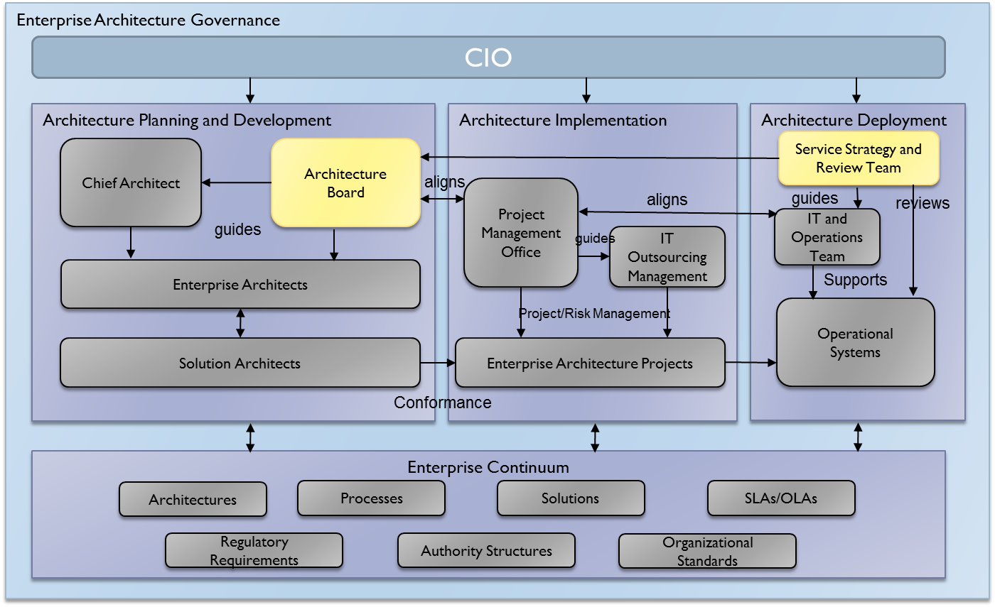
The CIO remains as the main personnel to oversee the Enterprise Architecture initiative from planning and development to implementation and eventually its deployment.
The Enterprise Architecture governance structure is divided into 3 parts:
- Architecture Planning and Development
- Architecture Implementation
- Architecture Deployment

The role and responsibilities of the personnel involved in the Enterprise Architecture Governance is described in the table below:
No | Job Title | Role and Responsibilities
1 | CIO | Overall decision maker. Oversees the Enterprise Architecture initiative from the planning to development to deployment
2 | Chief Architect | Key lead for Enterprise Architecture initiatives. Organizes the team for discussion and approval of the reviews.
3 | Architecture Board | A team of representatives from the architect team, business users, IT department. The main steering committee for the Enterprise Architecture initiative.
4 | Enterprise Architects | Main Enterprise Architecture team responsible for working on the Enterprise Architecture of SGLines.
5 | Solution Architects | The Solution Architects helps to provide technical expertise for the Enterprise Architects during their planning and development of the Enterprise Architecture.
6 | Project Management Office (PMO) | The PMO handles the implementation of the all Enterprise Architecture initiatives after the Enterprise Architects have confirmed the current projects to be implemented. This includes all outsourcing initiatives.
7 | IT and Operations Team | Handles the maintenance and support of the systems after deployment.
8 | Service Strategy and Review Team | Reviews the current services created and deployed and feedback to the Architecture Board for future improvements.

Processes for Architecture Compliance, Exceptions and Vitality
The following diagram describes the process for Architecture Compliance and Vitality.
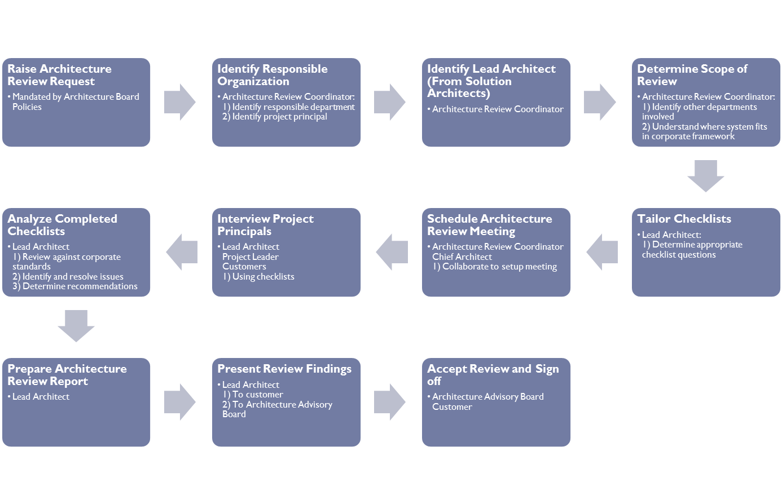
The following diagram describes the process for handling Architecture Exception
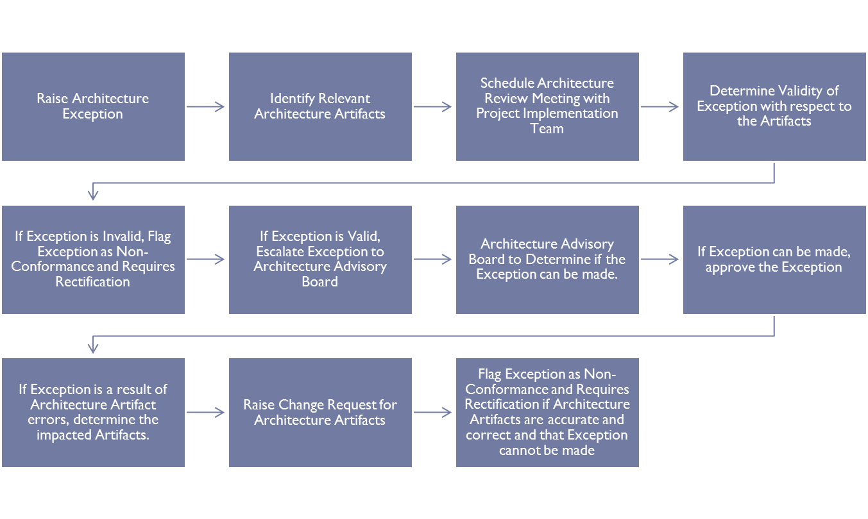

Governance Policies
The governance policies shall guide SGLines in the decision making process about the architecture. The policies are applicable throughout the Enterprise Architecture phases. The following lists the governance policies of SGLines:
- The Enterprise Architecture blueprint shall form the basis for all acquisition of systems for the purpose of fulfilling the business functions that require them.
- A single Enterprise Architecture Repository shall be established for the purpose of storing the artifacts and information so as to enable availability to these information for the entire enterprise.
- All regional units shall operate in accordance to the Enterprise Architecture blueprint that was set by the Enterprise Architecture team and approved by the Enterprise Architecture Board.
- There shall be strict compliance with the Enterprise Architecture vision, procedures and technical specifications set out in the blueprint. Any exceptions shall be raised and subjected to the Architecture Compliance process.
- All policies shall be reviewed yearly.

Governance Practices
The following practices are recommended for good architecture governance:
- Before any initiatives for business process and systems improvements, seek the Enterprise Architecture blueprint for guidelines and procedures before proceeding.
- Policies shall be in place for governing the use of Enterprise Architecture
- Any changes or amendments required for the Enterprise Architecture due to business process change and to adapt to the new business climate, change request for the Enterprise Architecture shall be raised and reviewed.
- Establish the roles and responsibilities of all stakeholders involved in the Enterprise Architecture initiatives.
- Adopt the use of tools and processes to help in the adoption of the Enterprise Architecture.
- Should there be any exceptions to the adoption of Enterprise Architecture, always consult the Chief Architect or raise an exception to the Architecture Board for review.

Skeletal Communication Plan
The following diagram proposes the skeletal communication plan of the organization with the Enterprise Architecture team:
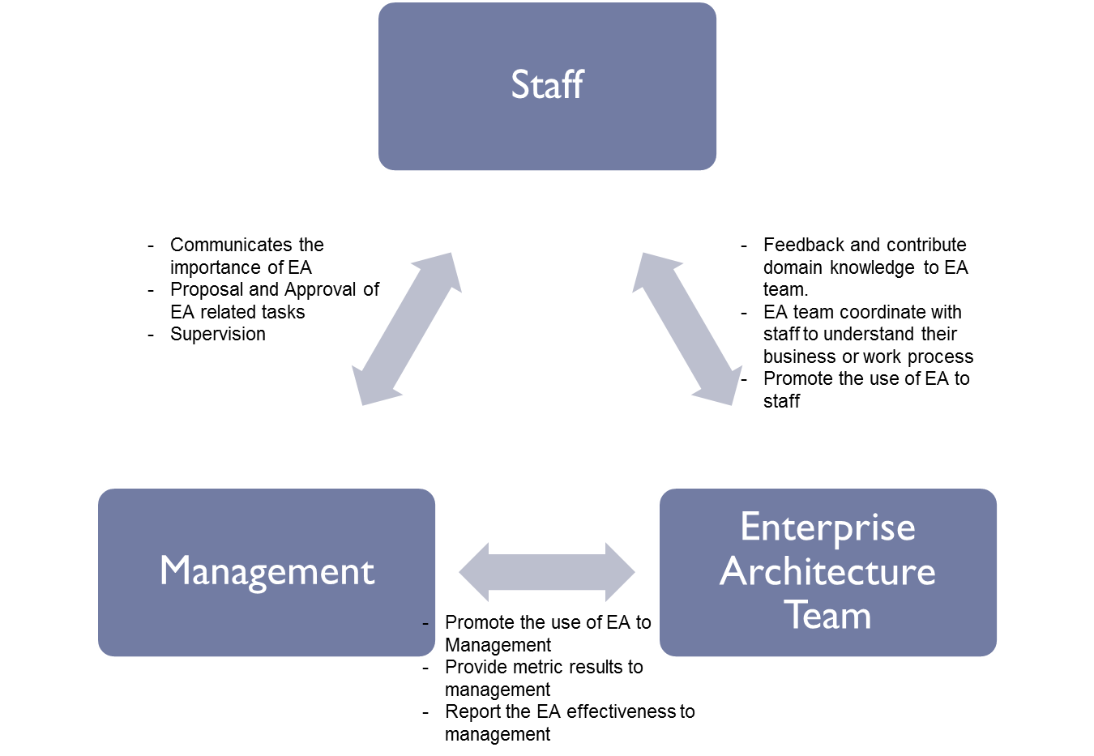

Change Management Process
The purpose of the architecture change management process is to ensure that there is a formal process to the review of the change by the Architecture Board, proper impact analysis shall be done and then approved by the board for adoption of the change. This shall ensure that all changes are reviewed and ensured that they are still in line with the overall business objectives and that the change shall not have a huge impact on the existing function of the Enterprise Architecture. After the change has been approved, the necessary artifacts and documents shall be updated in the Enterprise Architecture Repository. The following diagram shows the change management process:

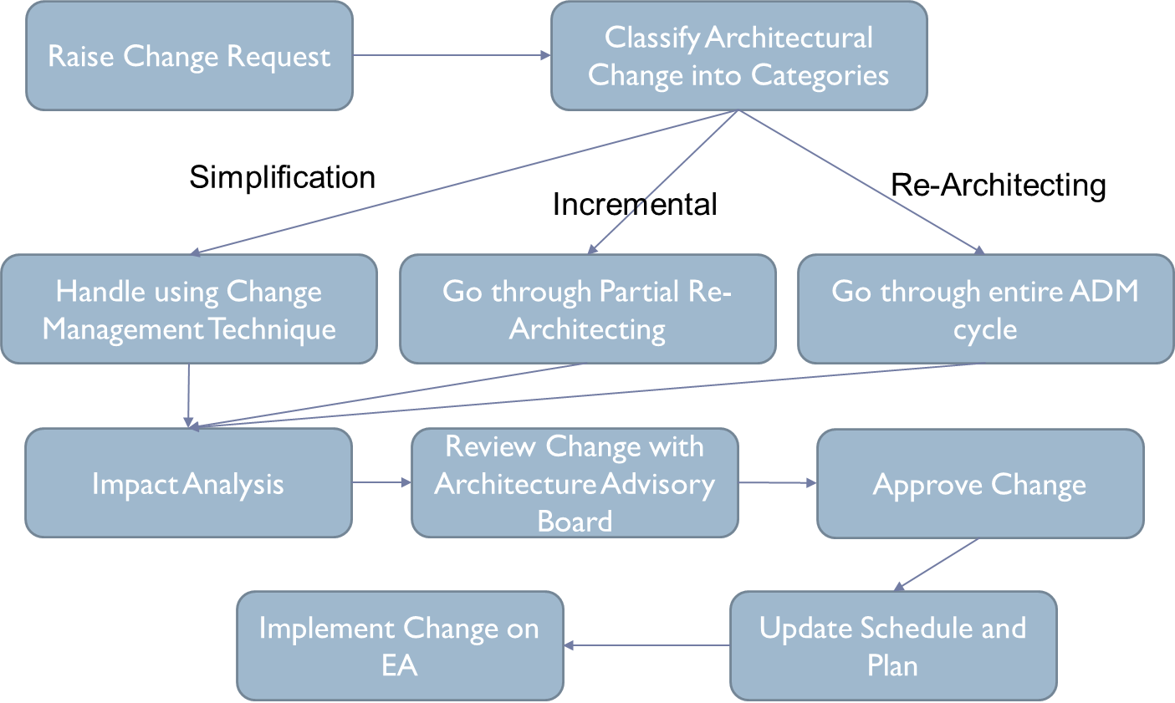

Guidance to Outsourcing Initiative
The following lists some of the outsourcing initiative guidance:
- Never outsource the entire EA function to a vendor.
- Only outsource the non-core functions or systems.
- Always do a Request for Proposal (RFP) before deciding on any vendor
- Evaluate and select vendor based on the value they offer and their expertise in the domain area.
- Avoid selecting the vendor that only offers the cheapest quotation.
- Ensure that the selected vendor has compliance with the target Enterprise Architecture principles.
- Manage the vendor by a development contract or service contract (SLA).
- Manage the vendor by the result they produce and evaluate and review the result with them regularly.
- Always communicate the portion of the organization’s Enterprise Architecture that the vendor is handling to the vendor to ensure they meet the requirements for development.

Metrics to Measure Effectiveness
The following metrics are selected to measure the effectiveness of the Enterprise Architecture so that any improvement initiatives could be tracked for effectiveness and changes made based on the metric results:
- Time taken for the customer to receive a Request for Quotation (RFQ) response.
- The amount of time that a customer’s shipment was delayed.
- The number of customer complaints per month for service non-fulfilment
- The number of new customers per month
- The turnaround time of the customer’s shipment.
- Amount of increased revenue annually

